Regulatory Committee
Meeting to be held on Wednesday, 19 September 2018

Electoral Division affected:
Wyre Rural Central;

Wildlife and Countryside Act 1981
Definitive Map Modification Order Investigation
Deletion and Addition of part of Bridleway 9 Winmarleigh at Island House
File No. 804-595
(Annex ‘A’ refers)

Contact for further information:
Claire Blundell, 01772 535604, Paralegal Officer, County Secretary and Solicitors Group, Claire.blundell@lancashire.gov.uk
Jayne Elliott, 01772 537663, Public Rights of Way Definitive Map Officer, Environment and Planning Group, jayne.elliott@lancashire.gov.uk

Executive Summary

The deletion from and addition to the Definitive Map and Statement of Public Rights of Way of part of Bridleway 9 Winmarleigh at Island House, Winmarleigh, in accordance with File No. 804-595.

Recommendation

(i) That the application to delete part of Bridleway 9 Winmarleigh through Island

House, in accordance with File No. 804-595, be accepted.

(ii) That the application to add a bridleway from a point on Bridleway 9 Winmarleigh passing through Island House to a further point on Bridleway 9 Winmarleigh, in accordance with File No. 804-595, be accepted.

(iii) That an Order be made pursuant to Section 53 (2)(b) and Section 53(3)(c)(iii) of the Wildlife and Countryside Act 1981 to delete from the Definitive Map and Statement of Public Rights of Way part of Public Bridleway No. 9 Winmarleigh through Island House, shown between points A-B1-C-D-E-F on the Committee plan.

(iv) That being satisfied that the test for confirmation can be met the Order be promoted to confirmation.

(v) That an Order be made pursuant to Section 53 (2)(b) and Section 53 (3)(b) and/or Section 53 (c)(i) of the Wildlife and Countryside Act 1981 to add to the Definitive Map and Statement of Public Rights of Way a public bridleway from a point on Public Bridleway 9 Winmarleigh to a further point on Public Bridleway 9 Winmarleigh as shown on the Committee Plan between points A-B2-G-H-I-J.

(vi) That being satisfied that the higher test for confirmation can be met the Order be promoted to confirmation.

Background

An application under Schedule 14 of the Wildlife and Countryside Act 1981 has been received for the deletion of part of Bridleway 9 Winmarleigh past Island House and shown by the solid bold line on the Committee plan between points A-B1-C-D-E-F and the addition of a bridleway from a point on Bridleway 9 Winmarleigh from Island House to a further point on Bridleway 9 Winmarleigh as shown on the Committee plan by a thick dashed line between points A-B2-G-H-I-J on the Definitive Map and Statement of Public Rights of Way.

The county council is required by law to investigate the evidence and make a decision based on that evidence as to whether a public right of way exists, and if so its status. Section 53(3)(b) and (c) of the Wildlife and Countryside Act 1981 set out the tests that need to be met when reaching a decision; also current Case Law needs to be applied.

An order will only be made to add a public right of way to the Definitive Map and Statement if the evidence shows that:
- A right of way “subsists” or is “reasonably alleged to subsist”

An order for adding a way to or upgrading a way shown on the Definitive Map and Statement will be made if the evidence shows that:
- “the expiration… of any period such that the enjoyment by the public…raises a presumption that the way has been dedicated as a public path or restricted byway”

An order for deleting a way shown on the Definitive Map and Statement will be made if the evidence shows that:
- That there is no public right of way over land shown in the map and statement as a highway as any description

When considering evidence, if it is shown that a highway existed then highway rights continue to exist (“once a highway, always a highway”) even if a route has since become disused or obstructed unless a legal order stopping up or diverting the rights has been made. Section 53 of the Wildlife and Countryside Act 1981 (as explained in Planning Inspectorate’s Advice Note No. 7) makes it clear that considerations such as suitability, the security of properties and the wishes of adjacent landowners cannot be considered. The Planning Inspectorate’s website also gives guidance about the interpretation of evidence.

The county council’s decision will be based on the interpretation of the evidence discovered by officers and documents and other evidence supplied by the applicant, landowners, consultees and other interested parties produced to the county council before the date of the decision. Each piece of evidence will be tested and the evidence overall weighed on the balance of probabilities. It is possible that the Council’s decision may be different from the status given in any original application. The decision may be that the routes have public rights as a footpath, bridleway, restricted byway or byway open to all traffic, or that no such right of way exists. The decision may also be that the routes to be added or deleted vary in length or location from those that were originally considered.

Consultations

Wyre Borough Council

Wyre Borough Council did not respond to consultations therefore it is presumed that they have no objections to the application.

Winmarleigh Parish Council

Winmarleigh Parish Council have not responded to consultations therefore it is presumed that they have no objections to the application.

Applicant/Landowners/Supporters/Objectors

The evidence submitted by the applicant/landowners/supporters/objectors and observations on those comments are included in Advice – Head of Service – Legal and Democratic Services Observations.

Advice

Head of Service – Planning and Environment

Points annotated on the attached Committee plan.

Point | Grid Reference (SD) | Description
A | 4575 4681 | Unmarked point on Bridleway 9 north of Island House
B1 | 4575 4680 | Stone wall across route
B2 | 4574 4680 | Route passes through gateway (no gate)
C | 4575 4680 | Route passes through wooden gate adjacent to Island House
D | 4575 4676 | Hedge/wooden area at south end of garden
E | 4575 4667 | Route passes through hedge
F | 4575 4667 | Unmarked junction with Footpath 8
G | 4573 4676 | Route passes through metal field gate
H | 4574 4673 | Route passes through gateway
I | 4574 4667 | Route crossed by metal field gate
J | 4574 4666 | Unmarked junction with Bridleway 9 and Footpath 8

Description of Routes

n.b. References to public rights of way shown on the Definitive Map and Statement are generally given in the form '02-14-BW09' or 'Bridleway Winmarleigh 9' but are referenced below in the abbreviated form 'Bridleway 9' for brevity since all those referred to are in Winmarleigh in Wyre Borough.

A site inspection was carried out in March 2018.

Island House was originally a working farm but has now been redeveloped as a residential property with further properties built which are accessed from the bridleway (north of point A).

Bridleway to be deleted

The bridleway to be deleted is part of Bridleway 9 and is shown on the Committee Plan between point A and point F; a distance of approximately 150 metres.

The route commences on the surfaced access track leading from Island Lane to Island House (Point A on the Committee plan). As the access track curves in a generally south westerly direction towards the gated entry to the property the route to be deleted continues in a straight (southerly) direction across a short section of mown grass verge to pass through a stone wall and continues generally south across a stone surfaced area adjacent to Island House and then through a gateway immediately east of the north east corner of Island House (point C).

Once through the gateway the route continues in a southerly direction adjacent to Island House and along a strip of garden adjacent to the property to point D where the garden ends at a row of trees and bushes.

From point D the route continues through an area of trees consisting of the remains of an old orchard, bushes and trees for approximately 25 metres and is currently impassable. It then emerges out of the trees to the rear of a partially built concrete stable block (east of point H).

The route passes through the stable block (no access) and continues south across an area of land that has been gravelled to provide access to the building and then across a grassed area adjacent to a static caravan to pass through a hedge at point E (no access) and join the track recorded as Footpath 8 at point F.

Bridleway to be added

The bridleway to be added is shown on the Committee plan between point A and point J; a distance of approximately 160 metres long.

From point A (on the existing route of Bridleway 9) the route follows the stoned access way leading to Island House passing through stone gateposts into the yard adjacent to the house. It continues in a south westerly then southerly direction between buildings across a partially cobbled and stone surfaced area which forms the driveway and parking area for the property.

The route continues south to a field gate (point G) which marks the boundary of Island House. It passes through the gateway and then continues south along a stoned track, through a further gateway (point H) and then follows a bounded track through another gateway (point I) to a junction of Bridleway 9 with Footpath 8 (point J).
The full length of the route to be added is currently accessible.

Map and Documentary Evidence

Document Title | Date | Brief Description of Document & Nature of Evidence
Yates’ Map  of Lancashire | 1786 | Small scale commercial map. Such maps were on sale to the public and hence to be of use to their customers the routes shown had to be available for the public to use. However, they were privately produced without a known system of consultation or checking. Limitations of scale also limited the routes that could be shown.
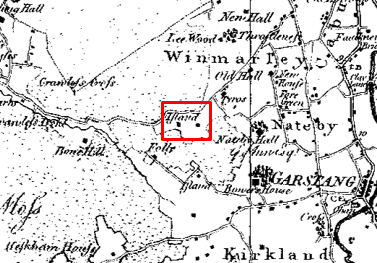
Observations |  | The application routes are not shown.  A building is shown in the location of Island House but access to the building or around the building is not shown.
Investigating Officer's Comments |  | No inference can be drawn with regards to the existence of public rights.
Greenwood’s Map of Lancashire | 1818 | Small scale commercial map. In contrast to other map makers of the era Greenwood stated in the legend that this map showed private as well as public roads and the two were not differentiated between within the key panel.
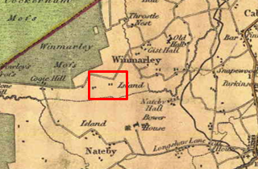
Observations |  | The application routes are not shown. Buildings labelled as 'Island' are shown in proximity of Island House but a route to, through or around the farm is not shown.
Investigating Officer's Comments |  | Access to the property probably existed in 1818 but no inference can be drawn with regards to whether the route continued beyond the property or the alignment of the route(s).
Hennet's Map of Lancashire | 1830 | Small scale commercial map. In 1830 Henry Teesdale of London published George Hennet's Map of Lancashire surveyed in 1828-1829 at a scale of 71/2 inches to 1 mile. Hennet's finer hachuring was no more successful than Greenwood's in portraying Lancashire's hills and valleys but his mapping of the county's communications network was generally considered to be the clearest and most helpful that had yet been achieved.
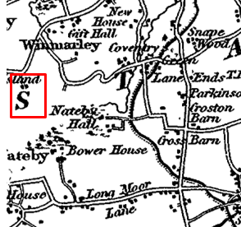
Observations |  | A route depicted by parallel solid lines is shown from Island Lane leading to buildings labelled Island but not beyond. The scale of the map means that it is not possible to identify whether the route shown forms part of either application route.
Investigating Officer's Comments |  | Access to the property existed in 1830 but no inference can be drawn with regards to whether the route continued through or past the farm or the alignment of the route(s).
Canal and Railway Acts |  | Canals and railways were the vital infrastructure for a modernising economy and hence, like motorways and high speed rail links today, legislation enabled these to be built by compulsion where agreement couldn't be reached. It was important to get the details right by making provision for any public rights of way to avoid objections but not to provide expensive crossings unless they really were public rights of way. This information is also often available for proposed canals and railways which were never built.
Observations |  | The application routes are not affected by any existing or proposed canal or railways.
Investigating Officer's Comments |  | No inference can be drawn with regards to the existence of public rights or the alignment of the route or routes.
Tithe Map and Tithe Award or Apportionment | 1849 | Maps and other documents were produced under the Tithe Commutation Act of 1836 to record land capable of producing a crop and what each landowner should pay in lieu of tithes to the church. The maps are usually detailed large scale maps of a parish and while they were not produced specifically to show roads or public rights of way, the maps do show roads quite accurately and can provide useful supporting evidence (in conjunction with the written tithe award) and additional information from which the status of ways may be inferred.
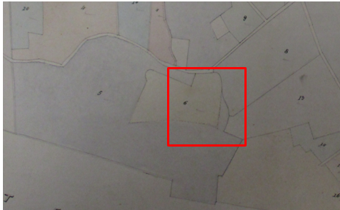
Observations |  | The Tithe Map for Winmarleigh was inspected and it was immediately noted that although the map showed numbered plots of land which corresponded to the field boundaries shown on the 1st edition 6 inch Ordnance Survey map no buildings had been drawn on the map and only the recognised public vehicular roads through the parish were shown. The application routes are located within the plot of land numbered 6 on the Tithe Map. The Tithe Award describes this plot as being known as 'Near Island' and the owners are listed as John Wilson Pattern and Richard Singleton. The land was occupied by James Cowparthwaite. There was no reference in the Tithe Award to the existence of the application routes.
Investigating Officer's Comments |  | No inference can be drawn with regards to the existence of public rights or correct alignment of the route.
Inclosure Act Award and Maps |  | Inclosure Awards are legal documents made under private acts of Parliament or general acts (post 1801) for reforming medieval farming practices, and also enabled new rights of way layouts in a parish to be made. They can provide conclusive evidence of status.
Observations |  | There is no Inclosure Award for Winmarleigh.
Investigating Officer's Comments |  | No inference can be drawn with regards to the existence of public rights or the correct alignment of the route.
6 Inch Ordnance Survey (OS) Map | 1847 | The earliest Ordnance Survey 6 inch map for this area surveyed in 1844-45 and published in 1847.
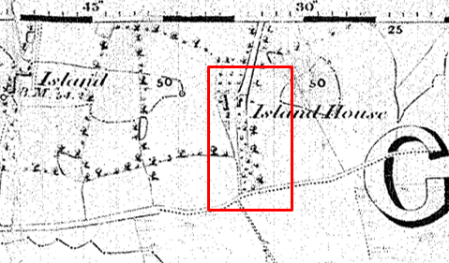
Observations |  | Island House is shown on the map with a bounded access route extending from Island Lane (north of the property). A route appears to be shown leading to the west side of Island House which is consistent with the route to be added and then continuing south to the junction with a track indicated by double pecked lines running east-west to the south of Island House (now recorded as Footpath 8).  A line can be seen across the route proposed to be deleted at point B1 and beyond that point the land is marked as being and area of woodland and the route to be deleted is not shown.
Investigating Officer's Comments |  | A route consistent with the route to be added appears to have existed in 1844-45. The route to be deleted does not appear to have existed.
25 Inch OS Map | 1892 | The earliest OS map at a scale of 25 inch to the mile. Surveyed in 1890-91 and published in 1892.
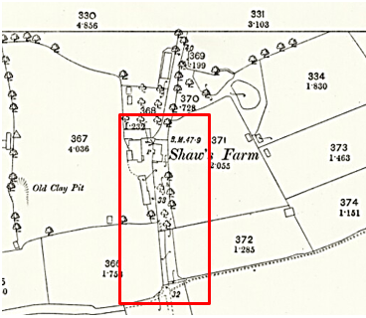
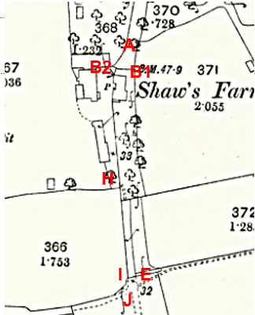
Observations |  | The larger scale map provides better detail than the earlier 6 inch scale map.  The name of the property is now shown as Shaw's Farm (formerly Island House).  The route to be deleted is not shown and lines are shown across it at point B1 and point E. There is also a line partway across the route adjacent to the building labelled as Shaw's Farm and south of the farm the land crossed by the route to be deleted is shown as an area planted with trees.  A route largely consistent with the route to be added may have been available. A line is shown across the route at point B2 and beyond that there is an open area between buildings which may have been accessible. A bench mark is located on the north west corner of the farm building passed by the route to be added and the letter P which probably indicates a pump at the side of the farm house.  South of point H a double pecked line (indicating a path) can be seen passing through the south west corner of the plantation to exit onto a bounded strip of land south east of point H (on the route to be added). The route to be added then continues in a generally southerly direction as a bounded route to point I where it appears to be gated and then along a track marked by double pecked lines to point K.
Investigating Officer's Comments |  | The route to be deleted did not exist in 1890-91. Access along a route largely consistent with the route to be added may have been available at that time.  Gateways, if they were found to exist, were shown by the surveyor in their closed position although this is not necessarily a true reflection of what may have been the position on the ground. A number of lines are shown across both the route to be deleted and the route to be added so it is necessary to look at this in context of features shown on the map in forming a view as to whether a gate, gap or stile may have been in existence at any given point. In doing so it appears reasonable to infer that access would have been available at points I but possibly not at point E and that it was unclear whether access was available or not at point B1 or B2 but that it was likely to be available via B2 as this leads into the farm yard and the angle of the line also suggests a gate at that point.  Bench marks were located along a line of levelling, and often followed lines of communication. However, they can also be found on rocks in the middle of private fields and consequently it cannot be assumed that a bench mark is indicative of a public right of way.  The 'P' in the farm yard could stand for a number of different things although 'Pump' is most likely in that context. However, none of the possible meanings (as listed in Richard Oliver (Ordnance Survey Maps: a concise guide for historians) relate to a right of way so no inference can be drawn from that.
25 inch OS Map | 1912 | Further edition of the 25 inch map surveyed in 1890-91, revised in 1910 and published in 1912.
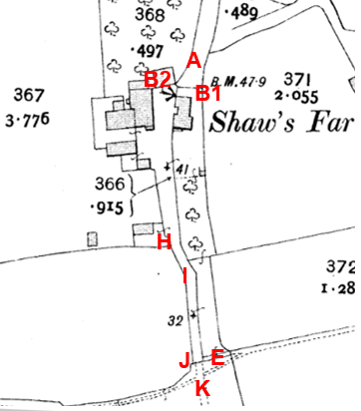
Observations |  | The route to be deleted is not shown and the route is crossed by solid black lines indicating the likely existence of a fence, wall or hedge at points B1 and E and north east of point I.  The route to be added appears to be accessible (with lines across it at points B2 and J) and provides a link from the access road (part of Bridleway 9 from Island Lane to the farm) and the continuation of the Bridleway through Helm Farm and Nateby Railway Station to the south (beyond point K).  Between point H and point I a route previously shown as a path through the corner of the plantation on the 1892 map has now been incorporated into a wider track providing a substantial bounded route from the farm to point J.
Investigating Officer's Comments |  | The route to be deleted probably did not exist in 1890-91.  The route to be added existed as part of a longer through route in 1910.
Finance Act 1910 Map | 1910 | The comprehensive survey carried out for the Finance Act 1910, later repealed, was for the purposes of land valuation not recording public rights of way but can often provide very good evidence. Making a false claim for a deduction was an offence although a deduction did not have to be claimed so although there was a financial incentive a public right of way did not have to be admitted.  Maps, valuation books and field books produced under the requirements of the 1910 Finance Act have been examined. The Act required all land in private ownership to be recorded so that it could be valued and the owner taxed on any incremental value if the land was subsequently sold. The maps show land divided into parcels on which tax was levied, and accompanying valuation books provide details of the value of each parcel of land, along with the name of the owner and tenant (where applicable).  An owner of land could claim a reduction in tax if his land was crossed by a public right of way and this can be found in the relevant valuation book. However, the exact route of the right of way was not recorded in the book or on the accompanying map. Where only one path was shown by the Ordnance Survey through the landholding, it is likely that the path shown is the one referred to, but we cannot be certain. In the case where many paths are shown, it is not possible to know which path or paths the valuation book entry refers to. It should also be noted that if no reduction was claimed this does not necessarily mean that no right of way existed.
Observations |  | The Finance Act Map for the area crossed by the application routes is not available to view in the County Records office.
Investigating Officer's Comments |  | No inference can be drawn with regards to the existence of public rights or the alignment of the route(s).
Plan of the Winmarleigh and Nateby Estate prepared in relation to the Sale of Estate land | 1912 | Estate plan reproduced from Ordnance Survey mapping prepared in relation to the sale of the Winmarleigh and Nateby Estate.  Source: Historic England Archives
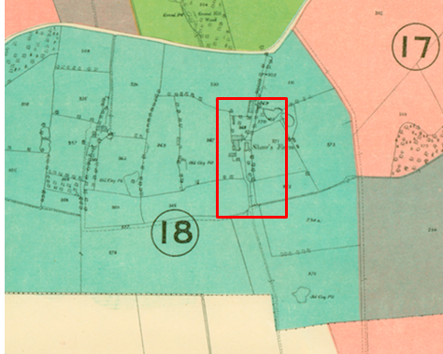
Observations |  | The Sales plan is derived from Ordnance Survey mapping and appears to be a copy of the 1912 25 inch map detailed above showing the route to be added as part of a longer through route but not showing the route to be deleted.  The land crossed by the application routes is coloured green and contained within Lot 18. The Schedule describes Lot 18 as Island Farm (or Shaw's Farm) in the occupancy of Mr Robert Reich. The property is described as a 'well known pasture farm' and the schedule gives details of each of individually numbered parcels of land within the Lot. Parcel 369 is described as an occupation road and on the 25inch OS map this numbered parcel includes the route to be deleted between point A and B1 and route to be added between point A and B2. The majority of both the route to be deleted (from point B2 to point E) and the route to be added (between point B2 and point I) are within parcel 366 on the OS base map but when the Estate plan was enlarged it was not possible to see this number and it is not listed in the Schedule. The remaining sections of the routes (Point E-point F and point I to point J) are within parcel 377 which is described as an arable field.
Investigating Officer's Comments |  | The Schedule does not refer to the existence of public rights or the alignment of both or either of the application routes so no inference can be drawn.
6 Inch OS Map | 1914 | Further edition of 6 inch map published 1914.
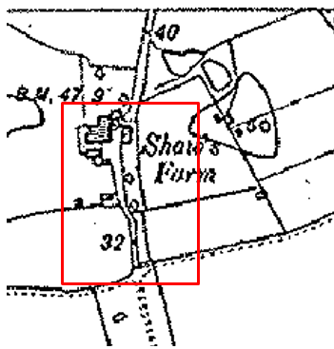
Observations |  | The small scale 6 inch map (enlarged) clearly shows the route to be added as being available as part of a longer route. The route to be deleted is not shown.
Investigating Officer's Comments |  | The route to be added existed in 1914. The route to be extinguished probably did not exist at that time.
Aerial Photograph | 1940s | The earliest set of aerial photographs available was taken just after the Second World War in the 1940s and can be viewed on GIS. The clarity is generally very variable.
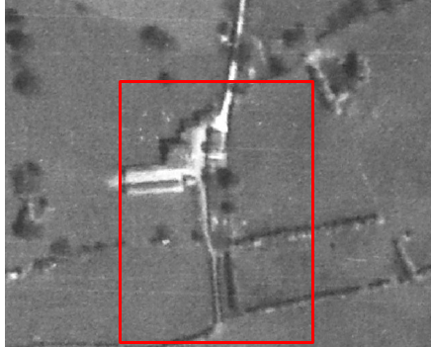
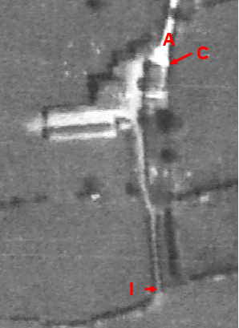
Observations |  | The photograph has been enlarged as far as possible in an attempt to see whether both (or either) routes were visible.  The route to be added is visible along its full length and appeared capable of being used. It was not possible however to see whether any gates existed across it.  The route to be deleted is not visible as a worn route on the ground except access does appear possible from point A along the east side of the farm house.
Investigating Officer's Comments |  | The route to be added existed in the 1940s but the route to de deleted probably did not exist.
6 Inch OS Map | 1955 | The OS base map for the Definitive Map, First Review, was published in 1955 at a scale of 6 inches to 1 mile (1:10,560). This map was revised before 1930 and is probably based on the same survey as the 1930s 25-inch map.
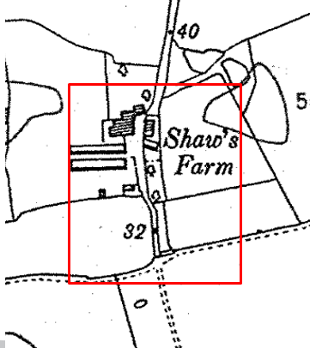
Observations |  | The route to be added is shown and looks to be the main route through the farm. A line is shown across the route at B1 and B2 suggesting the probable existence of a gate(s). The route to be deleted is not shown and is crossed by a number of boundary lines.
Investigating Officer's Comments |  | The route to be added existed in the 1930s (date of revision of the map) but the route to be deleted probably did not exist.
1:2500 OS Map | 1968 | Further edition of 25 inch map reconstituted from former county series and revised in 1967 and published 1968 as national grid series.
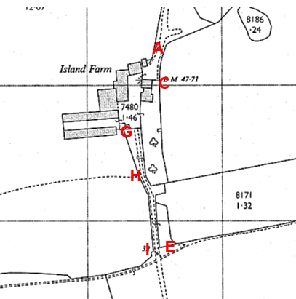
Observations |  | The route to be deleted is not shown. It is crossed by a solid line at point C and then four further lines before reaching point F.  The route to the farm (consistent with the route of Bridleway 9 from Island Lane, passes through point A to continue to point B2 beyond which a line is drawn across it between the corners of two buildings. A route appears to be available through the farmyard to point G where a line is drawn across the route from which point a track is shown to continue south consistent with the route to be added through to point I and J.
Investigating Officer's Comments |  | The route to be deleted is not shown on the map and probably did not exist in 1967.  The route to be added appears to be accessible as part of a longer through route and was probably gated at the north west corner of the farm (now Island House) and point G.
Aerial photograph | 1960s | The black and white aerial photograph taken in the 1960s and available to view on GIS.
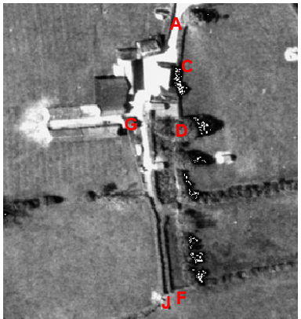
Observations |  | The route to be added from point A through to point J can be clearly seen and appears to have been accessible.  A route between point C and point D along the route to be deleted cannot be seen on the photograph but beyond point D a worn route consistent with pedestrian use (or possibly animals) can be seen running south to exit into the field to the east of point E.
Investigating Officer's Comments |  | The route to be added existed in the 1960s and appeared to be capable of being used. The route to be deleted does not appear to have existed in the 1960s although a route to the east and running parallel to it can be seen from point D. This route may have been accessible but is more likely to have been a track used by animals (as the farm was a dairy farm at that time).
1:10,000 OS Map | 1971 | 1:10,000 OS map published 1971.
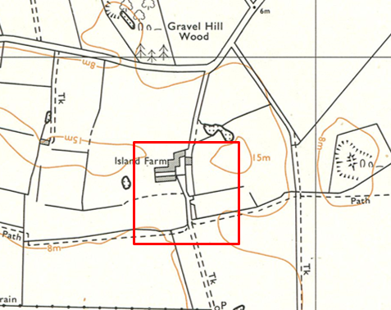
Observations |  | A stylised small scale map suggesting that access was not available along either route (due to the size of the farm buildings shown). This is, however unlikely to have been the case and was just a reflection of how the map was drawn. The route to be deleted is not shown and is crossed by a configuration of field boundaries. The route to be added is shown as a substantial track leading out of the farmyard. The property has been re-named again and is now shown as Island Farm.
Investigating Officer's Comments |  | No inference can be drawn.
Aerial Photograph | 1988 | Aerial photograph available to view at the County Records Office.
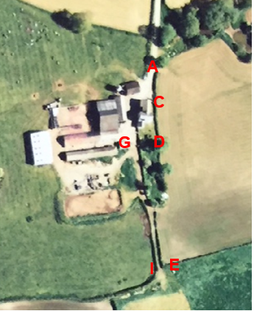
Observations |  | The route to be deleted is not visible as any sort of track on the photograph. The route to be added appears to be open and accessible.
Investigating Officer's Comments |  | The route to be deleted probably didn’t exist on the ground in 1988. The route to be added appears to have been available for use.
Definitive Map Records |  | The National Parks and Access to the Countryside Act 1949 required the county council to prepare a Definitive Map and Statement of Public Rights of Way.  Records were searched in the Lancashire Records Office to find any correspondence concerning the preparation of the Definitive Map in the early 1950s.
Parish Survey Map | 1950-1952 | The initial survey of public rights of way was carried out by the parish council in those areas formerly comprising a rural district council area and by an urban district or municipal borough council in their respective areas. Following completion of the survey the maps and schedules were submitted to the county council. In the case of municipal boroughs and urban districts the map and schedule produced, was used, without alteration, as the draft map and statement. In the case of parish council survey maps, the information contained therein was reproduced by the county council on maps covering the whole of a rural district council area. Survey cards, often containing considerable detail exist for most parishes but not for unparished areas.
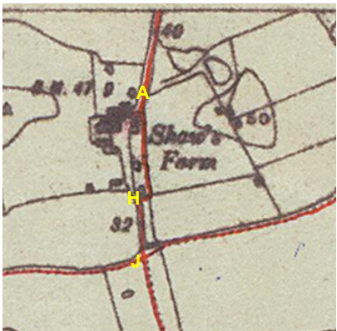
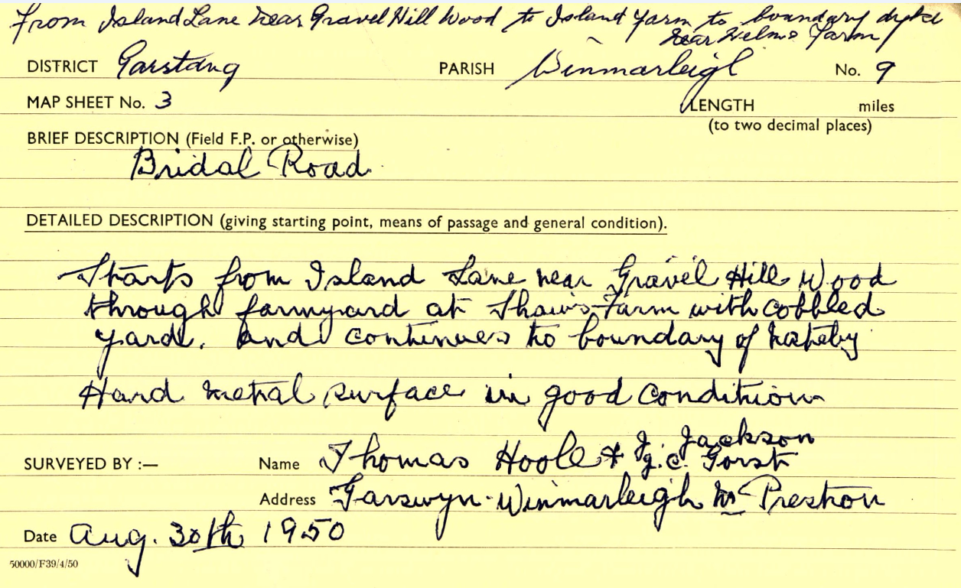
Observations |  | The parish survey map does not show the route entering the farmyard at Shaw's Farm (as named on the map) but shows it initially following the line of the route to be deleted to the east of the farm down the eastern side of a wooded plantation to a point directly in line with point H and then turning west to point H to continue south along the route to be added to point I and point J.  The parish survey card completed in August 1950 described the route as a 'Bridal Road' (sic) starting from Island Lane near Gravel Hill Wood 'through farmyard at Shaw's Farm with cobbled yard' continuing to the parish boundary with Nateby. It is further described as having a hard metalled surface in good condition.
Draft Map |  | The parish survey map and cards for Winmarleigh were handed to Lancashire County Council who then considered the information and prepared the draft map and statement.  The draft maps were given a “relevant date” (1st January 1953) and notice was published that the draft map for Lancashire had been prepared. The draft map was placed on deposit for a minimum period of 4 months on 1st January 1955 for the public, including landowners, to inspect them and report any omissions or other mistakes. Hearings were held into these objections, and recommendations made to accept or reject them on the evidence presented.
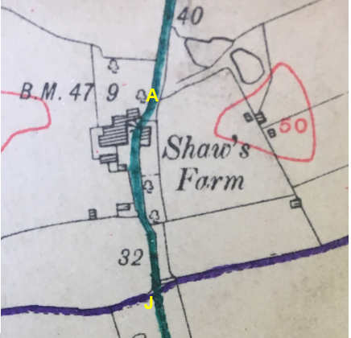
Observations |  | The route of the bridleway is shown as being the route to be added. The route to be deleted is not shown. There is no indication in the records held by the county council why the route shown on the draft map differed from that shown on the parish survey map and there were no objections to how it was shown or to the fact that the route to be deleted was not shown. The draft statement for the route of Bridleway 9 simply reads 'Island Lane to parish boundary'.
Provisional Map |  | Once all representations relating to the publication of the draft map were resolved, the amended draft map became the provisional map which was published in 1960, and was available for 28 days for inspection. At this stage, only landowners, lessees and tenants could apply for amendments to the map, but the public could not. Objections by this stage had to be made to the Crown Court.
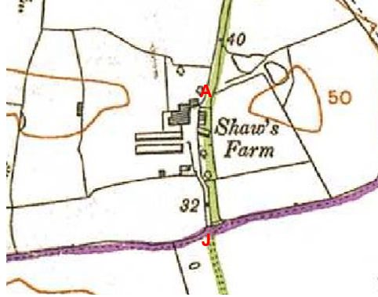
Observations |  | The route shown has altered again and is neither the route shown on the parish survey or the one shown on the draft map. The route has been drawn with a thick green line and is largely consistent with the route proposed to be deleted. The route to be added is not shown. There were no formal objections made to how the route was shown or the fact that the route to be added was not shown.
The First Definitive Map and Statement |  | The provisional map, as amended, was published as the definitive map in 1962.
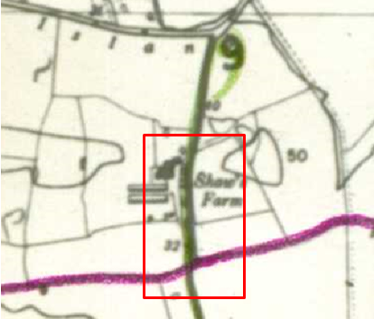
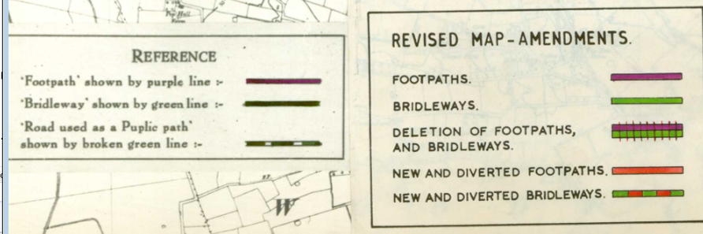
Observations |  | The route to be deleted is marked with a dark green line east of Island House. The green line is so dark however that the detail of the OS base map cannot be seen. The lighter green line appears to coincide with the route to be added from point A to B2 and H to J. The key shows the lighter green to be the amendments on the revised map suggesting that a correction was intended, showing the bridleway further west although still unclear and seemingly drawn through the farmhouse.
Revised Definitive Map of Public Rights of Way (First Review) |  | Legislation required that the definitive map be reviewed, and legal changes such as diversion orders, extinguishment orders and creation orders be incorporated into a definitive map first review. On 25th April 1975 (except in small areas of the County) the Revised Definitive Map of Public Rights of Way (First Review) was published with a relevant date of 1st September 1966. No further reviews of the definitive map have been carried out. However, since the coming into operation of the Wildlife and Countryside Act 1981, the definitive map has been subject to a continuous review process.
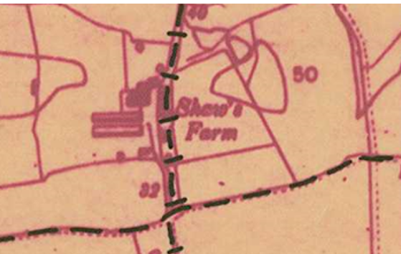
Observations |  | The application route is shown along the route to be deleted. The route to be added is not shown.
Investigating Officer's Comments |  | It has been found across Lancashire that (a) the small scale (6 inch to 1 mile) of the OS maps used to prepare the Parish Survey, Draft, Provisional, First Definitive and Revised Definitive Map (First Review) (b) the thickness of the pens used to draw the lines to the denote the routes and (c) the fact that the maps were drawn and then reproduced at least 5 times during the process – it is not known by whom – have resulted in a significant number of drafting errors occurring on maps in some areas, particularly where the base map is unclear or cluttered.  In this particular case the first inconsistency can be found in the parish survey and parish survey card. The parish survey card is very specific in how it described the route of the bridleway passing through the yard at Shaw's Farm, making reference to the cobbled surface but the parish survey map does not show the route through what is believed to have been the farmyard and the two are not only at odds with one another but are at odds with how the route is then subsequently shown on the draft map, provisional map, first definitive and revised definitive map.  The draft map differs from how the route was shown on the parish survey map and then there are further differences with how it is shown on the provisional and first definitive map (drawn with thick pen lines). Perhaps most indicative is that the first definitive map sheets were used for the draft or provisional revised map which were subsequently transcribed onto the sheets which became the Revised Definitive Map (which is the current one). The dark green line of the first definitive map appears to have been corrected by the lighter green line for the revised map but the amendment put the line through the old farmhouse, presumably because the details had been obscured by the dark line and the poor quality of the base map.  Without any evidence that the route of the bridleway was challenged at any point from 1953 through to 1966 it therefore appears most likely that drafting errors have occurred in respect of the correct route through the farm and that it is therefore necessary to look at how the route was described in the parish survey card and all available map and documentary evidence from the time before and around the time the route was first recorded.
Highway Adoption Records including maps derived from the '1929 Handover Maps' | 1929 to present day | In 1929 the responsibility for district highways passed from district and borough councils to the county council. For the purposes of the transfer, public highway 'handover' maps were drawn up to identify all of the public highways within the county. These were based on existing Ordnance Survey maps and edited to mark those routes that were public. However, they suffered from several flaws – most particularly, if a right of way was not surfaced it was often not recorded.  A right of way marked on the map is good evidence but many public highways that existed both before and after the handover are not marked. In addition, the handover maps did not have the benefit of any sort of public consultation or scrutiny which may have picked up mistakes or omissions.  The county council is now required to maintain, under section 31 of the Highways Act 1980, an up to date List of Streets showing which 'streets' are maintained at the public's expense. Whether a road is maintainable at public expense or not does not determine whether it is a highway or not.
Observations |  | Neither route is recorded on the List of Streets or shown as adopted highways on highway records maintained by the county council.
Investigating Officer's Comments |  | No inference can be drawn with regards to the existence of public rights or the alignment of the route(s).
Statutory deposit and declaration made under section 31(6) Highways Act 1980 |  | The owner of land may at any time deposit with the county council a map and statement indicating what (if any) ways over the land he admits to having been dedicated as highways. A statutory declaration may then be made by that landowner or by his successors in title within ten years from the date of the deposit (or within ten years from the date on which any previous declaration was last lodged) affording protection to a landowner against a claim being made for a public right of way on the basis of future use (always provided that there is no other evidence of an intention to dedicate a public right of way).  Depositing a map, statement and declaration does not take away any rights which have already been established through past use. However, depositing the documents will immediately fix a point at which any unacknowledged rights are brought into question. The onus will then be on anyone claiming that a right of way exists to demonstrate that it has already been established. Under deemed statutory dedication the 20 year period would thus be counted back from the date of the declaration (or from any earlier act that effectively brought the status of the route into question).
Observations |  | No Highways Section 31(6) deposits have been lodged with the county council for the area over which the application routes run.
Investigating Officer's Comments |  | There is no indication by a landowner under this provision of non-intention to dedicate public rights of way over their land.
Photograph submitted by applicant | c.2006 | Photograph of driveway submitted by applicant and said to have been taken when he purchased the property in approximately 2006.
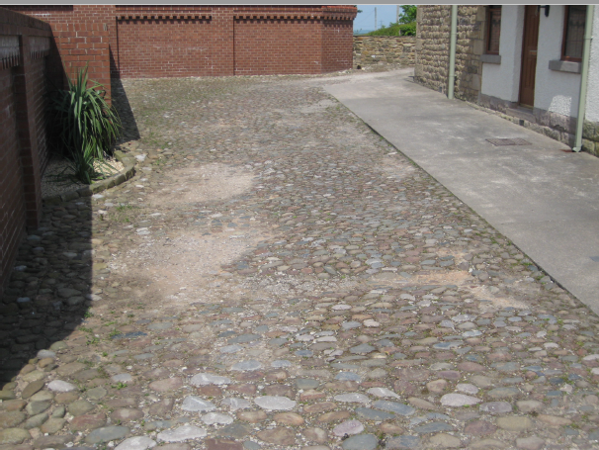
Observations |  | The photograph shows the driveway of Island House over which the route to be added runs between point B2 and point G and shows part of the cobbled yard which the applicant explains was in existence prior to him resurfacing the driveway.
Investigating Officer's Comments |  | The photograph shows that the previous surface of the driveway (former farmyard) was cobbled which is consistent with the description of the route of the bridleway passing through the cobbled yard as Shaw's Farm. The route to be deleted passes to the east of the farm house across an area now landscaped as a garden. No evidence of a cobbled (or previously cobbled) surface along that section (C-D) has been found which suggests that the route described in the parish survey card was consistent with the route to be added.

The affected land/specified parts of the land is not designated as access land under the Countryside and Rights of Way Act 2000 and is not registered common land.

Landownership

The land is in private ownership with 2 different properties affected, including the applicant. Mineral rights are owned by Duchy of Lancaster.

Summary

The Investigating Officer was of the view that all the map and documentary evidence submitted as part of the application, or examined as part of the detailed research carried out by the county council, shows that the route to be deleted had, on a balance of probabilities, never existed. It also showed that there had consistently been a way available on the route to be added.

Taking all available map and documentary evidence into consideration it is considered that the route to be deleted was wrongly recorded and that the route of the bridleway is that shown available on the various Ordnance Survey maps and described in the parish survey card passing through the cobbled farmyard at Shaw's Farm (the route to be added) and not the route to be deleted.

No map or documentary evidence examined supported the view that two parallel routes existed or had existed in the past or that the route has moved or been altered either legally (by a diversion or dedication) or informally.

Head of Service – Legal and Democratic Services Observations

Information from the Applicant

The application was supported by the following:

- Statement in support of modification of bridleway 9 – Ian Terry 22 March 2018
- Statement from Mr R Grayston 10 February 2018
- Statement from Mr Andrew Grayston 12 January 2018
- Plan to accompany application
- Photograph of cobbled driveway on purchase by Ian Terry referred to in statement 22 March 2018
- Photograph "Route believed to be correct west of house"
- Photograph "Disputed route to east of house"
- Photograph "Route of disputed path running through ancient hedge"
- Photograph "Route (through gate) believed to be correct
Documentary evidence not provided as already in possession of Lancashire county council per advice of Jayne Elliott:
- Ordnance survey 6 inch map published 1847 (Lancashire XLIV)
- Ordnance survey 25 inch map published 1892 (Lancashire XLIV.2)
- Ordnance survey 25 inch map published 1912 (Lancashire XLIV.2)
- Ordnance survey 6 inch map published 1914 (Lancashire XLIV.NW)
- Ordnance survey 1:25000 map published 1954 (sheet SD44)
- Draft map
- Parish survey card 30.8.50
- Aerial photographs from 1940's, 1999 and 2013.

Mr Ian Terry provides that Bridleway 9 has always followed the application route to be added through the property now known as Island House (previously known as Island Farm, Shaw's Farm and Island House). It is a historical track which is enclosed by ancient hedges for much of its length. For as long as there have been reliable maps, there has never been a path through the property along the application route to be deleted although this is where it appears on the definitive map. Mr Terry believes that the route was incorrectly recorded on the definitive map due to a drafting error and hopes the application will correct this error.

Mr Andrew Grayston provided in his statement that he lived at Elm Farm from 1968 until 1996 and that there was always a bridle path through Elm Farm and Island Farm that followed the application route to be added on the enclosed track to the cobbled farm yard. There has never been a path of any kind running to the east of Island House, this has always been a fenced garden.

Mr R. B. Grayston also previously lived at Elm Farm. He was born, lived and farmed there since 1939. He was also friendly with the family who lived there and regularly used the application route to be added. He is not aware of there ever having been any kind of path running to the east of Island House.

Information from the Landowners

The landowner of the southern part of the application routes provided some photos in support of the application.

Information from others

None

Assessment of the Evidence

The Law - See Annex 'A'

In Support of the application for the addition of the bridleway A-B2-G-H-I-J

- Use by the public
- Available route
- Documentary evidence

Against accepting the application for the deletion of A-B2-G-H-I-J

- No particular evidence against
In support of the application for the deletion of path A-B1-C-D-E-F

- Documentary evidence
- Alternative route in existence
- Information from landowners

Against accepting the application for the deletion of path A-B1-C-D-E-F

- Initial presumption that it exists as it was recorded on Definitive Map and Statement by due process

Conclusion

In this matter it is claimed that the line shown on the Definitive Map from point A-B1-C-D-E-F is shown in error and instead it is claimed that there is a bridleway on a line between points A-B2-G-H-I-J.

To delete a bridleway from the definitive map requires cogent evidence that there was an error made in putting it on the map. In 1950 -1952, the Parish Survey Map first recorded the route this is shown on a different line to the routes claimed for the addition and deletion. The Draft Map shows the route of the bridleway as being the route to be added. The Provisional Map shows the route altered again and it is neither the route shown on the parish survey map nor the one shown on the draft map although largely consistent with the route to be deleted. The First Definitive Map and Statement shows the claimed route to be deleted marked with a dark green line and the claimed route to be added coincides with a lighter green line which suggests, as supported by the key, that a correction was intended.

There appears to be no evidence to suggest the line of the bridleway on the map was challenged at any point from 1953-1966. It is reasonable on balance that there have been drafting errors in depicting the route through the farm. It is therefore necessary to look at how the route was described in the parish survey map and documentary evidence from the time before and around the time it was first recorded. The earlier Ordnance Survey map from 1847 shows a route consistent with the route to be added appears to have existed in 1844-45. The route to be deleted does not appear to have existed.

The parish survey card completed in August 1950 described the route as a 'Bridal Road' (sic) starting from Island Lane near Gravel Hill Wood 'through farmyard at Shaw's Farm with cobbled yard'. The photograph provided by a landowner shows the driveway of Island House over which the route to be added runs between point B2 and point G and shows part of the cobbled yard which the applicant explains was in existence prior to him resurfacing the driveway. The photograph shows that the previous surface of the driveway (former farmyard) was cobbled which is consistent with the description of the route of the bridleway passing through the cobbled yard at Shaw's Farm. The route to be deleted passes to the east of the farm house across an area now landscaped as a garden. No evidence of a cobbled (or previously cobbled) surface along that section (C-D) has been found which suggests that the route described in the parish survey card was consistent with the route to be added.

The line A -J can be considered to subsist as a bridleway does not necessarily prove that the line nearby A-F was recorded in error. The Committee should consider whether it is unlikely that the two bridleways existed so close to each other or whether there was only one route which should have been recorded but instead A-F was recorded in error.

In this matter there seems a possibility on balance that as a result of the recording exercise conducted from the 1950's an error may have been made with regard to recording the exact line of the bridleway.

It is suggested that Committee may consider that on balance there is evidence by way of all map and documentary evidence that the route claimed for deletion was recorded on its line in error and should have been recorded as A-B2-G-H-I-J. The map and documentary evidence suggests on balance that the route to be deleted did not exist on the ground.

Alternative options to be considered - N/A

Local Government (Access to Information) Act 1985

List of Background Papers

Paper | Date | Contact/Directorate/Tel
All documents on File Ref: 804-595 |  | Claire Blundell, 01772 535604, County Secretary and Solicitors Group
Reason for inclusion in Part II, if appropriate

N/A

The Ordnance Survey (OS) has produced topographic maps at different scales (historically one inch to one mile, six inches to one mile and 1:2500 scale which is approximately 25 inches to one mile). Ordnance Survey mapping began in Lancashire in the late 1830s with the 6-inch maps being published in the 1840s. The large scale 25-inch maps which were first published in the 1890s provide good evidence of the position of routes at the time of survey and of the position of buildings and other structures. They generally do not provide evidence of the legal status of routes, and carry a disclaimer that the depiction of a path or track is no evidence of the existence of a public right of way.
o? Aerial photographs can show the existence of paths and tracks, especially across open areas, and changes to buildings and field boundaries for example. Sometimes it is not possible to enlarge the photos and retain their clarity, and there can also be problems with trees and shadows obscuring relevant features.

